PL/SQL HANDS-ON
CREATING TABLE
CREATE TABLE Customers (
CustomerID NUMBER PRIMARY KEY,
Name VARCHAR2(100),
DOB DATE,
Balance NUMBER,
LastModified DATE,
IsVIP CHAR(1) DEFAULT 'N' -- Added for VIP status
);

CREATE TABLE Accounts (
AccountID NUMBER PRIMARY KEY,
CustomerID NUMBER,
AccountType VARCHAR2(20),
Balance NUMBER,
LastModified DATE,
FOREIGN KEY (CustomerID) REFERENCES Customers(CustomerID)
);

CREATE TABLE Transactions (
TransactionID NUMBER PRIMARY KEY,
AccountID NUMBER,
TransactionDate DATE,
Amount NUMBER,
TransactionType VARCHAR2(10),
FOREIGN KEY (AccountID) REFERENCES Accounts(AccountID)
);

CREATE TABLE Loans (
LoanID NUMBER PRIMARY KEY,
CustomerID NUMBER,
LoanAmount NUMBER,
InterestRate NUMBER,
StartDate DATE,
EndDate DATE,
FOREIGN KEY (CustomerID) REFERENCES Customers(CustomerID)
);

CREATE TABLE Employees (
EmployeeID NUMBER PRIMARY KEY,
Name VARCHAR2(100),
Position VARCHAR2(50),
Salary NUMBER,
Department VARCHAR2(50),
HireDate DATE
);
INSERTING DATA:
INSERT INTO Customers VALUES (1, 'John Doe', TO_DATE('1960-05-15','YYYY-MM-DD'), 12000, SYSDATE, 'N');
INSERT INTO Customers VALUES (2, 'Jane Smith', TO_DATE('1990-07-20','YYYY-MM-DD'), 8000, SYSDATE, 'N');
INSERT INTO Accounts VALUES (1, 1, 'Savings', 1000, SYSDATE);
INSERT INTO Accounts VALUES (2, 2, 'Checking', 1500, SYSDATE);
INSERT INTO Transactions VALUES (1, 1, SYSDATE, 200, 'Deposit');
INSERT INTO Transactions VALUES (2, 2, SYSDATE, 300, 'Withdrawal');
INSERT INTO Loans VALUES (1, 1, 5000, 5, SYSDATE, ADD_MONTHS(SYSDATE, 20));
INSERT INTO Employees VALUES (1, 'Alice Johnson', 'Manager', 70000, 'HR', TO_DATE('2015-06-15', 'YYYY-MM-DD'));
INSERT INTO Employees VALUES (2, 'Bob Brown', 'Developer', 60000, 'IT', TO_DATE('2017-03-20', 'YYYY-MM-DD'));
EXERCISE 1:CONTROL STRUCTURES
SCENERIO 1
BEGIN
FOR rec IN (SELECT l.LoanID, l.InterestRate
FROM Loans l JOIN Customers c ON l.CustomerID = c.CustomerID
WHERE MONTHS_BETWEEN(SYSDATE, c.DOB)/12 > 60) LOOP
UPDATE Loans
SET InterestRate = rec.InterestRate - 1
WHERE LoanID = rec.LoanID;
END LOOP;
DBMS_OUTPUT.PUT_LINE('Discount applied to loans for customers over 60.');
END;
/
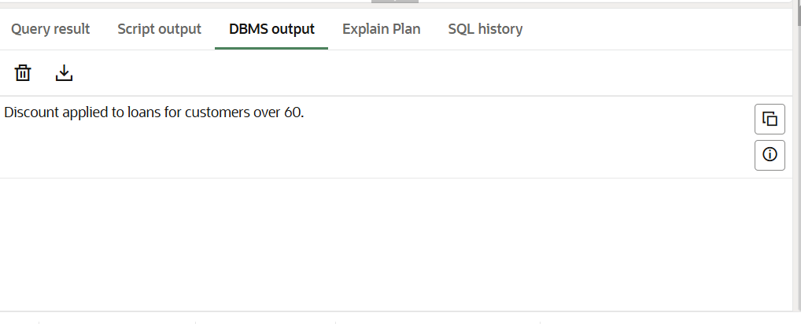
SCENERIO 2:
BEGIN
FOR cust IN (SELECT CustomerID FROM Customers WHERE Balance > 10000) LOOP
UPDATE Customers
SET IsVIP = 'Y'
WHERE CustomerID = cust.CustomerID;
END LOOP;
DBMS_OUTPUT.PUT_LINE('VIP status updated for eligible customers.');
END;
/
OUTPUT
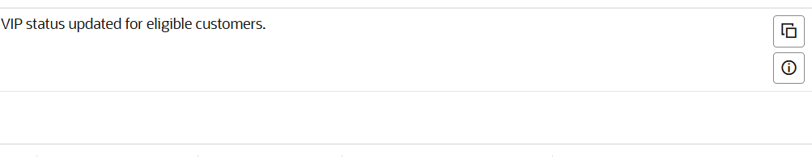
SCENERIO 3
INSERTING VALUES:
INSERT INTO Loans (LoanID, CustomerID, LoanAmount, InterestRate, StartDate, EndDate)
VALUES (2, 2, 3000, 4.5, SYSDATE, SYSDATE + 15);
BEGIN
FOR rec IN (SELECT c.Name, l.EndDate
FROM Loans l JOIN Customers c ON l.CustomerID = c.CustomerID
WHERE l.EndDate BETWEEN SYSDATE AND SYSDATE + 30) LOOP
DBMS_OUTPUT.PUT_LINE('Reminder: ' || rec.Name || ', your loan is due on ' || TO_CHAR(rec.EndDate, 'YYYY-MM-DD'));
END LOOP;
END;
/
OUTPUT

EXERCISE 3:STORED PROCEDURES

CREATE OR REPLACE PROCEDURE ProcessMonthlyInterest IS
BEGIN
FOR acc IN (SELECT AccountID, Balance
FROM Accounts
WHERE AccountType = 'Savings') LOOP
UPDATE Accounts
SET Balance = Balance + (Balance * 0.01),
LastModified = SYSDATE
WHERE AccountID = acc.AccountID;
END LOOP;

DBMS_OUTPUT.PUT_LINE('Monthly interest processed for all savings accounts.');
END;
/
EXAMPLE CALL
BEGIN
ProcessMonthlyInterest;
END;
/
OUTPUT

SCENERIO 2
CREATE OR REPLACE PROCEDURE UpdateEmployeeBonus (
dept_name IN VARCHAR2,
bonus_pct IN NUMBER
) IS
BEGIN
UPDATE Employees
SET Salary = Salary + (Salary * bonus_pct / 100)
WHERE Department = dept_name;

DBMS_OUTPUT.PUT_LINE('Bonus applied to ' || dept_name || ' department.');
END;
/
SAMPLE CALL
BEGIN
UpdateEmployeeBonus('IT', 10);
END;
/
OUTPUT
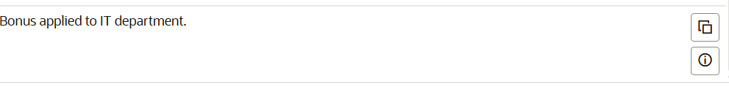

SCENERIO 3
CREATE OR REPLACE PROCEDURE TransferFunds (
from_account IN NUMBER,
to_account IN NUMBER,
amount IN NUMBER
) IS
insufficient_funds EXCEPTION;
BEGIN
DECLARE
from_balance NUMBER;
BEGIN
SELECT Balance INTO from_balance FROM Accounts WHERE AccountID = from_account FOR UPDATE;
IF from_balance < amount THEN
RAISE insufficient_funds;
END IF;
UPDATE Accounts
SET Balance = Balance - amount,
LastModified = SYSDATE
WHERE AccountID = from_account;
UPDATE Accounts
SET Balance = Balance + amount,
LastModified = SYSDATE
WHERE AccountID = to_account;
DBMS_OUTPUT.PUT_LINE('Transfer of $' || amount || ' successful.');
EXCEPTION
WHEN insufficient_funds THEN
DBMS_OUTPUT.PUT_LINE('Error: Insufficient funds.');
END;
END;
/
SAMPLE CALL:
BEGIN
TransferFunds(1, 2, 200);
END;
/
OUTPUT:
